CIRCULAR: 2010HOC0459MW 26thJuly 2010

TO: ALL MEMBERS NO 13 REGION

C.c. Executive Council Members
Regional Officials
Brigade Officials

Dear Brother/Sister,

ELECTION OF REGIONAL SECRETARY – REGION 13

I am pleased to inform you that the only other candidate having declined to accept nomination, Brother John Drake has been re-elected unopposed to the above position.

Best wishes.

Yours fraternally,
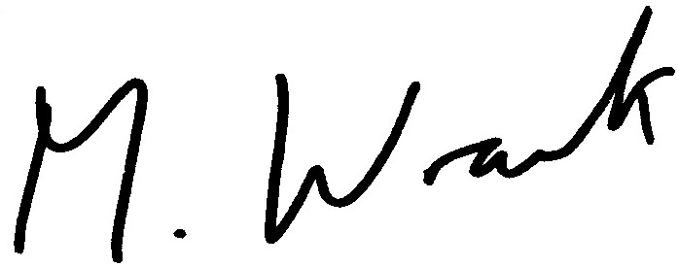

MATT WRACK
General Secretary

MW/PW/JW

