CIRCULAR: 2010HOC0453SS

22nd July 2010

TO: ALL MEMBERS

Dear Brother/Sister,

NATIONAL SCHOOL 2010

Please find attached an application form for the 2010 National School. This is being circulated earlier than in previous years to allow ample time for leave to be arranged.

It is not a prerequisite to be an Official of the Union to attend National School. However it is hoped that Branch, Brigade and other Officials will apply, including those who have previously attended the first year of a National School.

This year’s school will cover a wide variety of issues including: organising and improving industrial relations within the UK FRS; challenges facing trade unions and the public sector as well as a range of wider industrial and political issues of concern to the union and its members. Participants will have an opportunity to consider our strategy and campaign priorities for the future.

Attendance at National School is also a great opportunity to meet new people from various Regions and for networking.

A range of speakers have already agreed their attendance and the School offers members the opportunity to increase their awareness and understanding on a range of subjects, both within the UK Fire Service and on wider national and international trade union issues.

Applications should be sent to:

National School Application
Sean Starbuck - Education Officer
Fire Brigades Union
Bradley House
68 Coombe Road
Kingston upon Thames
Surrey KT2 7AE.

Members will receive confirmation that their application has been received and a place confirmed.

Once confirmed all applicants are expected to attend and ensure they have secured the required leave. Trade union leave may be available and this would need to be arranged through local officials.

All reasonable travel and subsistence payments will be met in line with the union’s Education Policy.

Yours fraternally,

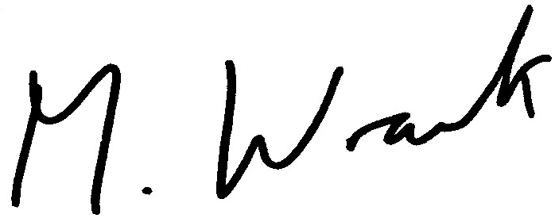

MATT WRACK
General Secretary

Attachment

SS/EMH

